TK1150 SERIES ON-CHIP VERSION
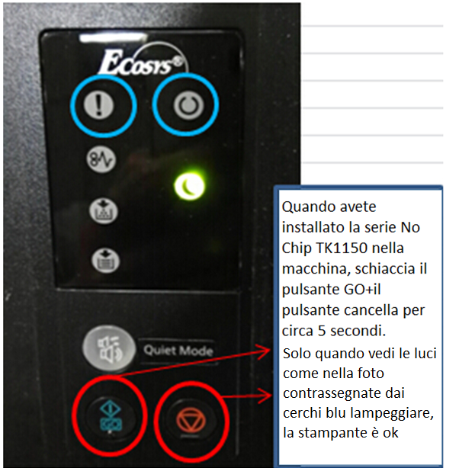

TK1160/1170 SERIES ON-CHIP VERSION

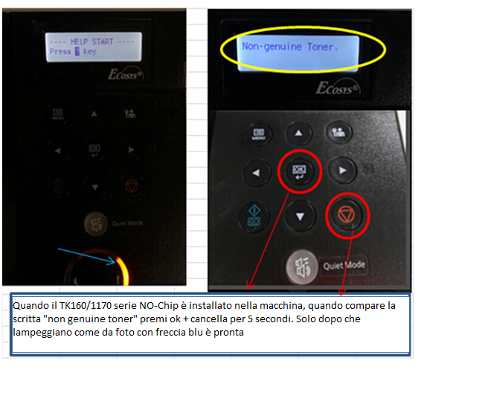

TK3160 SERIES ON-CHIP VERSION

